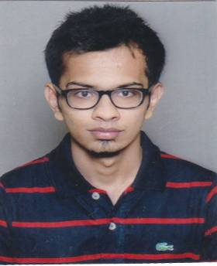

Milan Sailesh Gandhi

Tel: +91 9898045928

E-Mail: milan.dgr8@gmail.com

Currently in BARODA
Objective - Seeking entry level assignment in Sales & Marketing with an organization of high repute.
Educational Qualifications -

Stream | University / Board | Institution | Year | Gpa /  Marks
B.B.A. | Jadavpur University | JDBI, Dept. of Management | 2016 | 7.39 CGPA
Class XII | C.B.S.E | Apeejay School | 2013 | 90%
Class X | C.B.S.E | Apeejay School | 2011 | 7.6(CGPA)
Summer Internship Experience -

A) Videocon D2H – Kolkata, West Bengal, Presently Working since March 16 to April 16
Videocon d2h is an Indian pay TV company, providing direct broadcast satellite service—including satellite television, audio programming, and interactive television services—to commercial and residential customers in India

Job Profile-
- Looking after Sales & Marketing services of the valuable customers of Videocon D2H.
- Generating leads & conducting market research.
Extra Curricular Activities & Achievements -
- Secretary, Interact Club(Apeejay School)
- School House Captain(Apeejay School)
- Participated in R.D. Parade(Dance and march past)
- Inter school Dance competition(Odyssey)
- 2nd position Green warrior skit(Greenpeace)
- Inter school Quiz
- Won third price in Treasure Hunt for Xavier’s Management Convention
- Won Second price in Field Event for Xavier’s Management Convention
Computer Skills -
- Microsoft Office (Word, Excel, Power Point and Outlook)
- Internet Skills – Browsing, E-mails

Personal Dossier -
- Date of Birth; December 24, 1994
- Nationality; Indian
- Marital Status; Single
- Permanent Address; 31/D Chakraberia Road (South) , Kolkata -700025
- Present Address - B -203, Aashray Flats , Near Javernagar Bus stop , Waghodia Road –Baroda -390019

I hereby declare that all the information provided by me in this application is factual and correct to the best of my knowledge and belief.


Milan Sailesh Gandhi

